 | 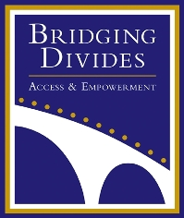 |  | 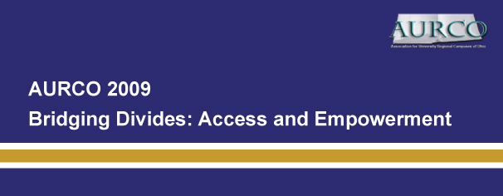
 | Conference:  Saturday  April 4  7:45 a.m.-4:20 p.m.  Welcome reception:  Friday  April 3  6:00-9:00 p.m.  Both held at the  Miami University Middletown  Campus Community Center  Hosted by    4200 E. University Blvd.  Middletown, OH 45042  www.mid.muohio.edu  aurco2009@muohio.edu  513-727-3406 |  | Association for University Regional Campuses of Ohio 2009 Conference  Thanks to everyone who attended the 15th annual AURCO Conference  at Miami University Middletown!  The AURCO Planning Committee wishes to thank the individuals and organizations listed here who assisted us in making the conference happen!  In an era that promises to be a watershed for higher education in Ohio, and for regional campuses in particular, there is no better way to share insights and develop collegial relationships than by participating in this year’s AURCO Conference. Faculty, staff, and students will find many opportunities to appreciate both the diversity of ideas and commonality of interests at Ohio’s regional campuses.
  AURCO 2009 Home
  Registration
  Lodging/Hospitality
  Program
  Contact Us
  Map & Directions
  KEYNOTE SPEAKER | KEYNOTE PRESENTATION
  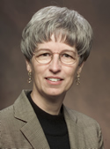  Dr. Marcia Baxter Magolda | Learning Partnerships: Helping Students  Develop Self-Authorship  Abstract: Marcia Baxter Magolda will share narratives from her 22-year study of young adult learning and development, highlighting cognitive, identity, and relational growth necessary for achieving common college learning goals. Discussion of video clips of these narratives will give participants an opportunity to explore the extent to which their students experience this developmental journey. Marcia will also describe the Learning Partnerships Model and how to use reflective conversations to promote growth away from authority-dependence toward self-authorship, or the internal capacity to choose one’s beliefs, values, identity, and relationships.  To read more about Marcia Baxter Magolda and her work, please CLICK HERE.

